**USER EXPERIENCE**



NAMA : IRVIANTO CATUR SAPUTRA

NIM : 1801388531

**WIREFRAME**

**SPLASH SCREEN**

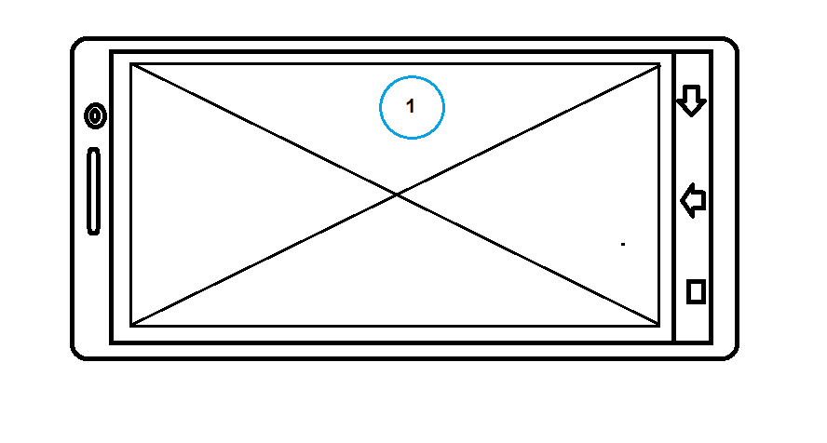

1. **LOGO GAME**

**LOADING**

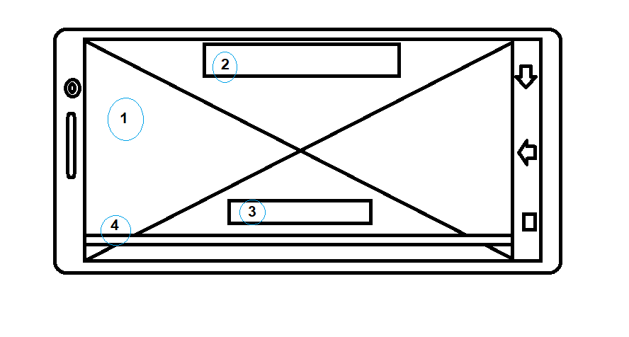

1. **IMAGE GAME/ EVENT**
2. **GAME NAME**
3. **NOTIF/ PEMBERITAHUAN**
4. **LOADING BAR**

**LOGIN**

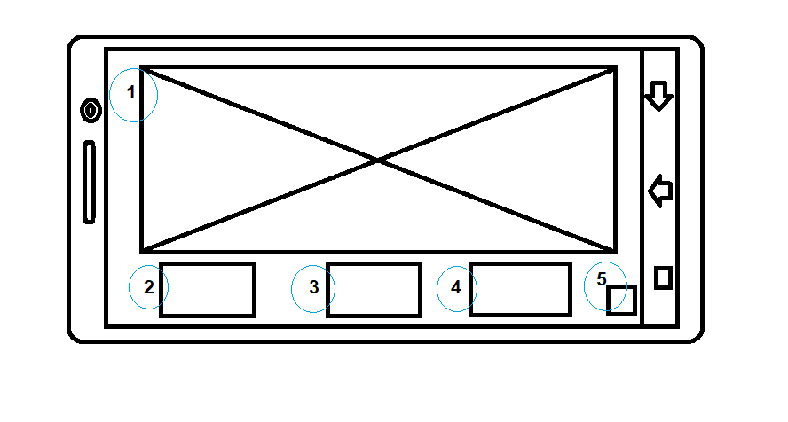

1. **IMAGE GAME/EVENT**
2. **LOGIN GOOGLE ACCCOUNT**
3. **LOGIN FACEBOOK ACCOUNT**
4. **LOGIN GUEST**
5. **QUIT GAME**

**MAIN MENU**

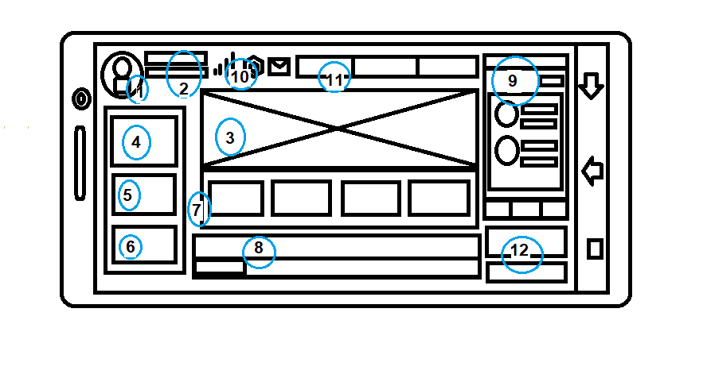

1. **FOTO PROFILE**
2. **NAME AND LEVEL**
3. **GAME IMAGE/EVENT**
4. **SHOP**
5. **IVENTORY**
6. **CLAN**
7. **CHOICE MATCH**
8. **CHAT**
9. **FRIEND LIST**
10. **SETTING, MESSAGE, SINYAL**
11. **MONEY**
12. **GIFT EVENT**

**SHOP**

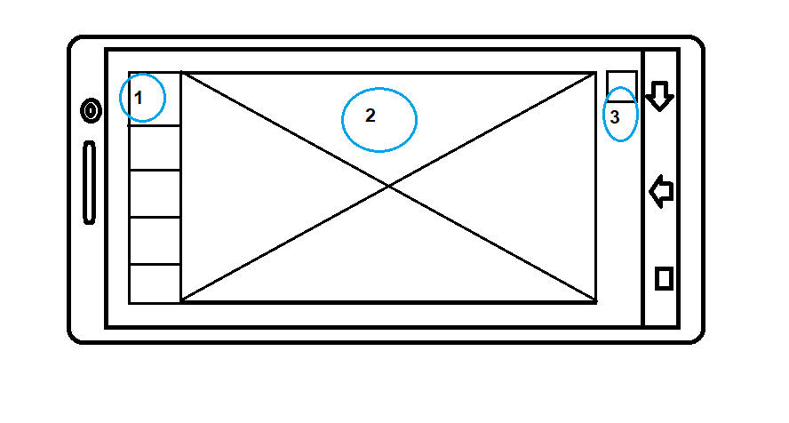

1. **LIST ITEM HERO DSB**
2. **DETAIL ITEM HERO DSB**
3. **BACK**

**OPTION**

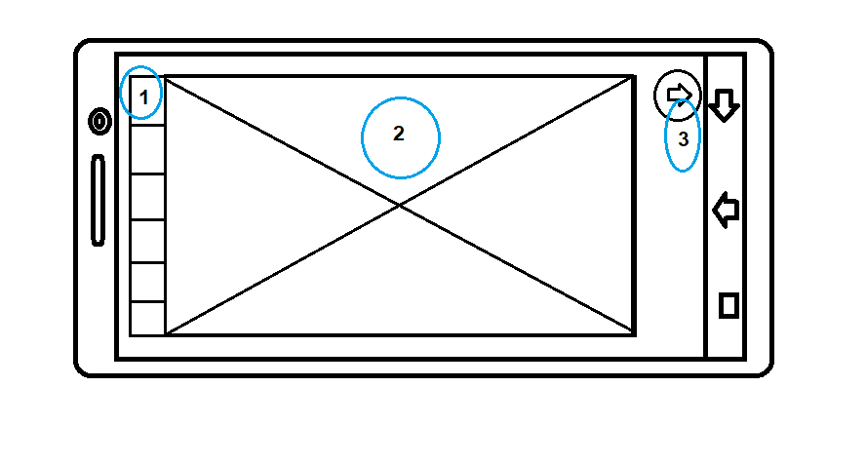

1. **LIST OPTION**
2. **DETAIL OPTION**
3. **BACK**

**FRIEND**

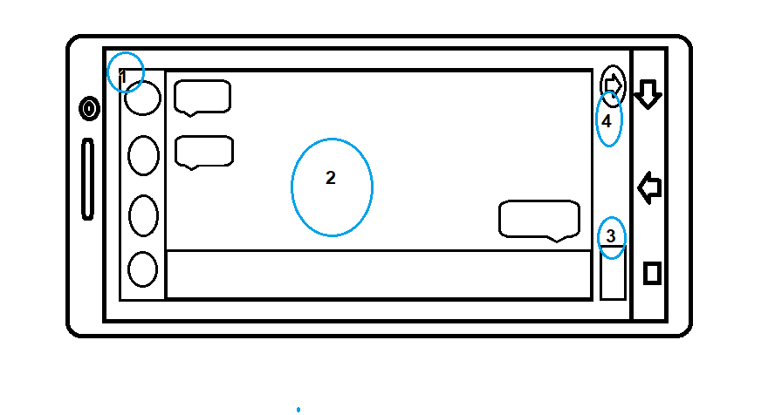

1. **LIST FRIEND**
2. **CHAT**
3. **FRIEND REQUEST**
4. **BACK**

**MESSAGE/REWARD**

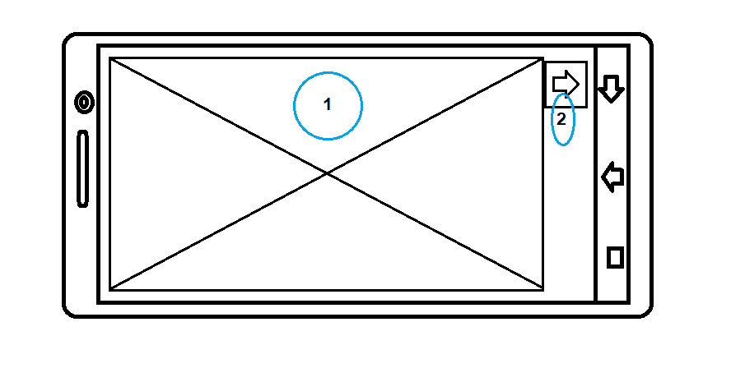

1. **MESSAGE/REWARD**
2. **BACK**

**INVENTORY**

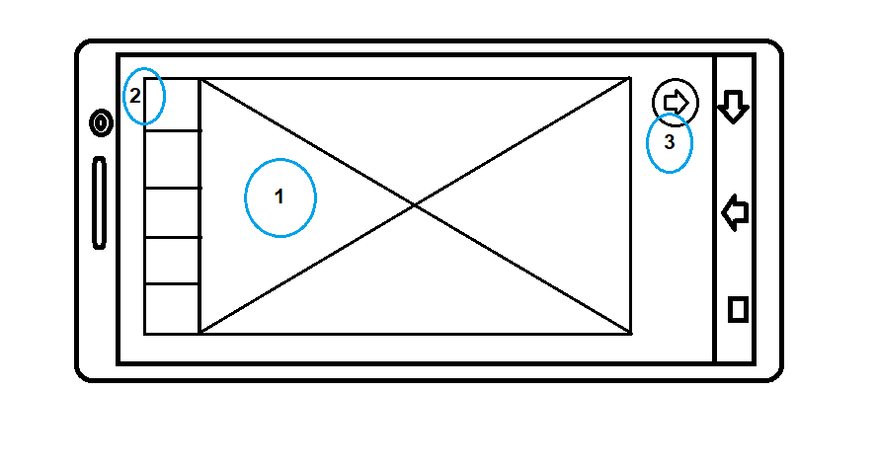

1. **DETAIL INVENTORY**
2. **LIST INVENTORY**
3. **BACK**

**PREMATCH**

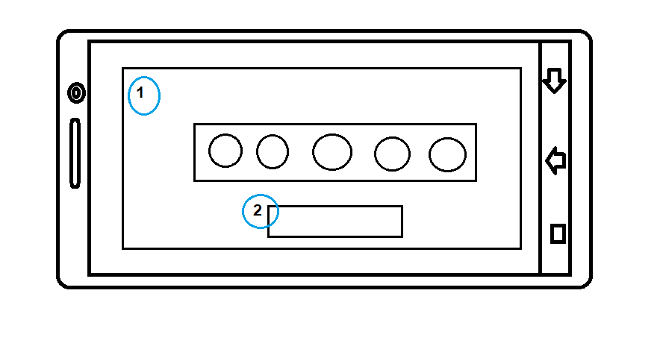

1. **IMAGE GAME DAN LIST PLAYER**
2. **READY BUTTON**

**PICK HERO**

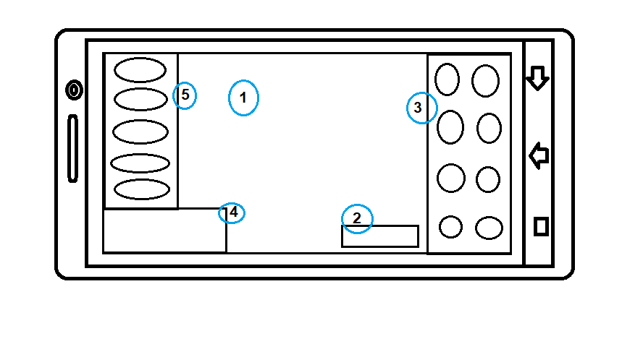

1. **IMAGE/3D HERO**
2. **READY BUTTON**
3. **LIST HERO**
4. **CHAT**
5. **TEAM**

**LOADING MATCH**

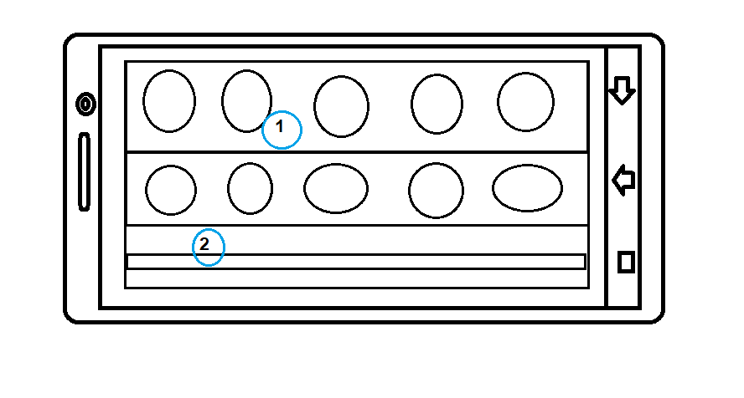

1. **TEAM AND OPPONENT**
2. **LOADING BAR**

**END GAME**

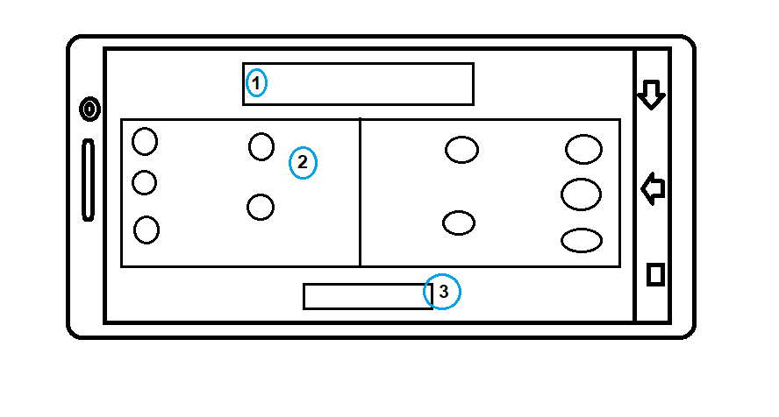

1. **VICTORY/LOSS**
2. **TEAM AND OPPONENT SCORE**
3. **BACK LOBBY**

**GAMEPLAY**

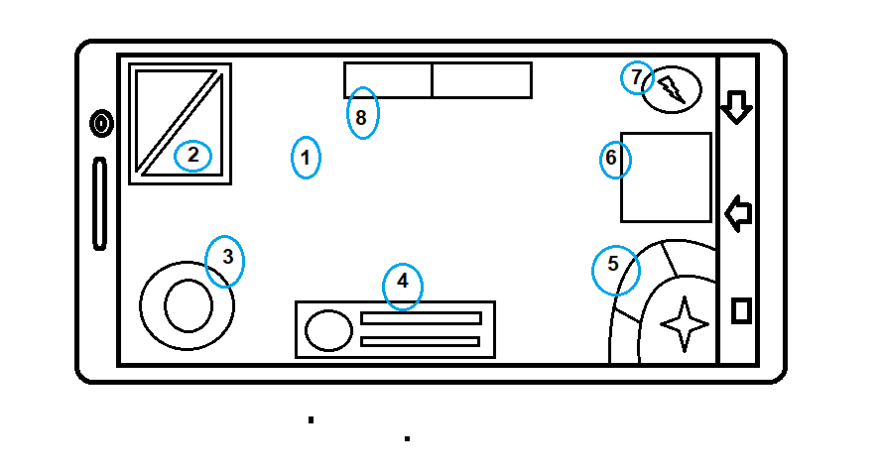

1. **GAME MATCH**
2. **MINI MAP**
3. **ANALOG/CONTROLER**
4. **STATUS HERO, HP AND SP**
5. **ATTACK AND SKILL**
6. **CHAT**
7. **SHOP IN GAME**

**CLAN**

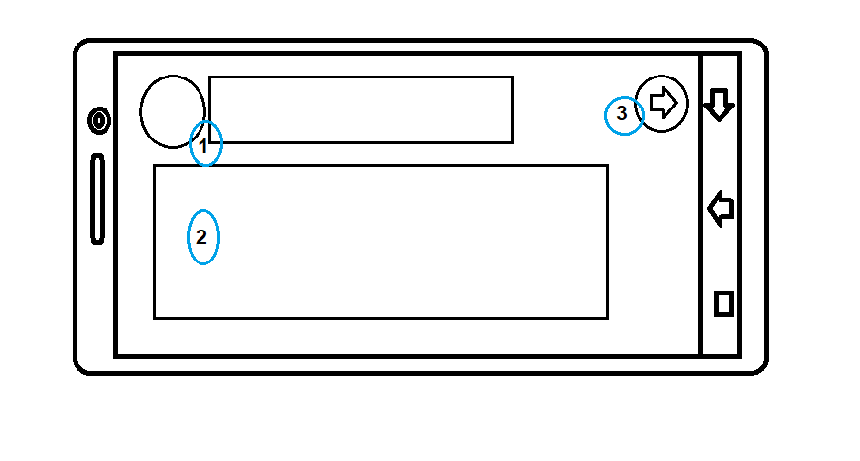

1. **DETAIL CLAN**
2. **MEMBER CLAN**
3. **BACK**

**SITEMAPS**

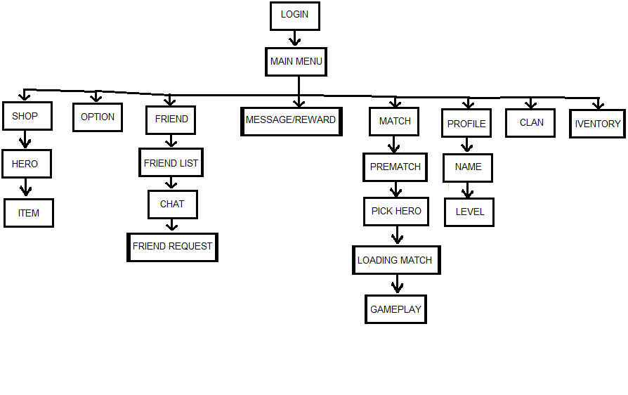

**TASKFLOW**

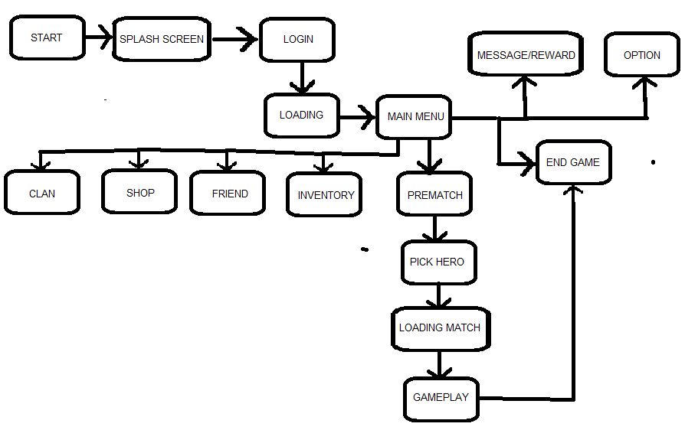

**PROTOTYPE**

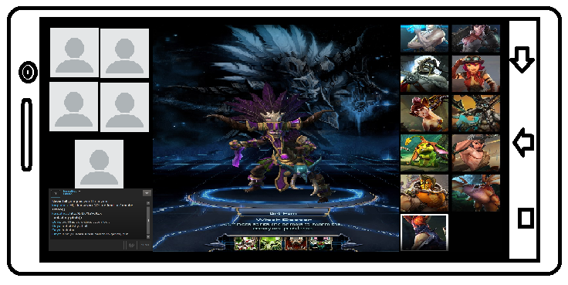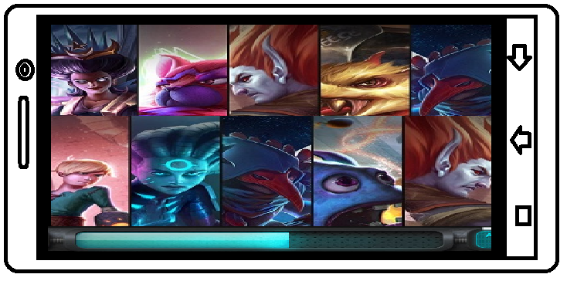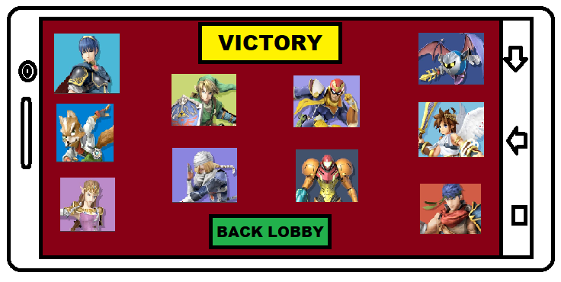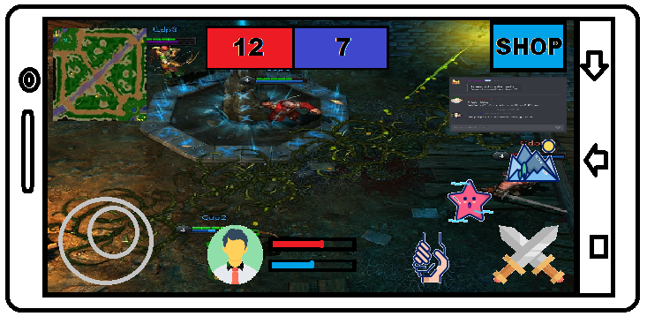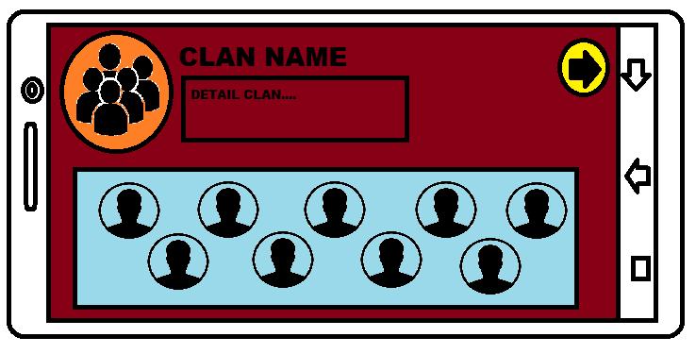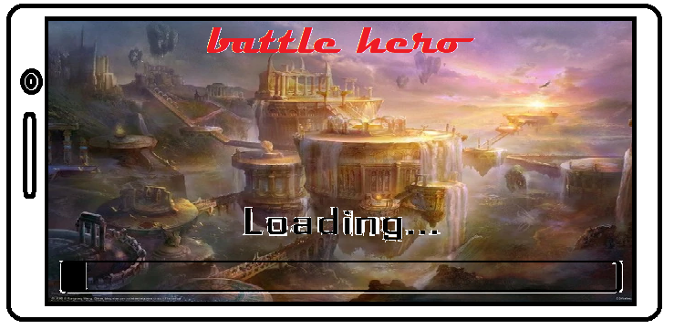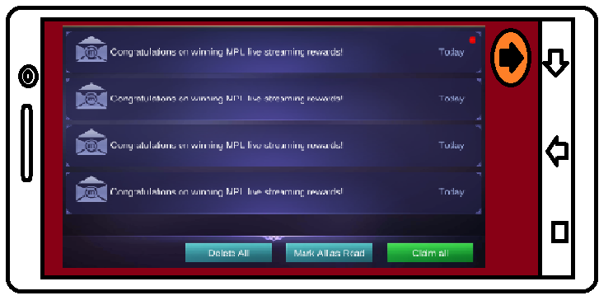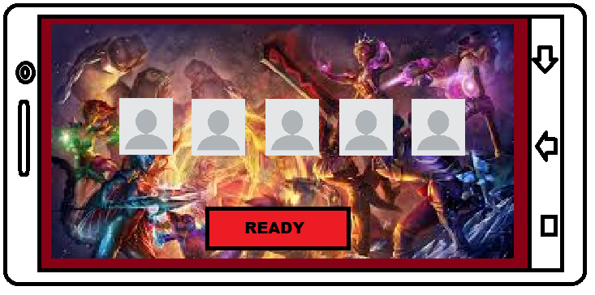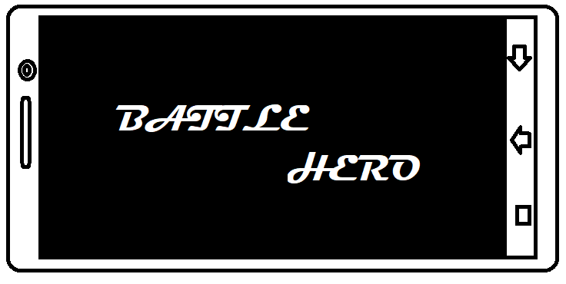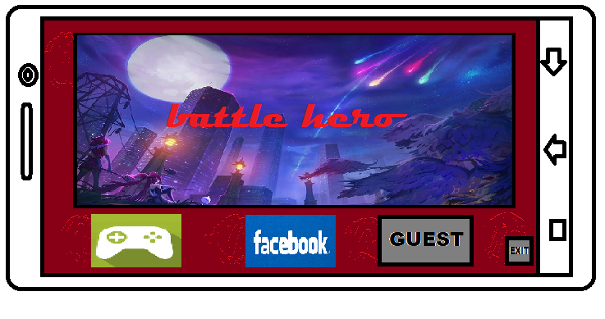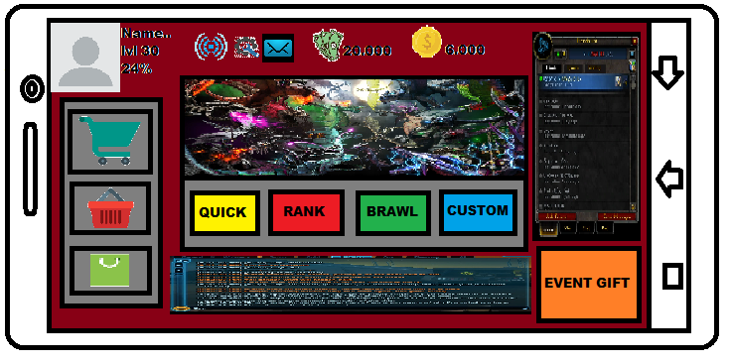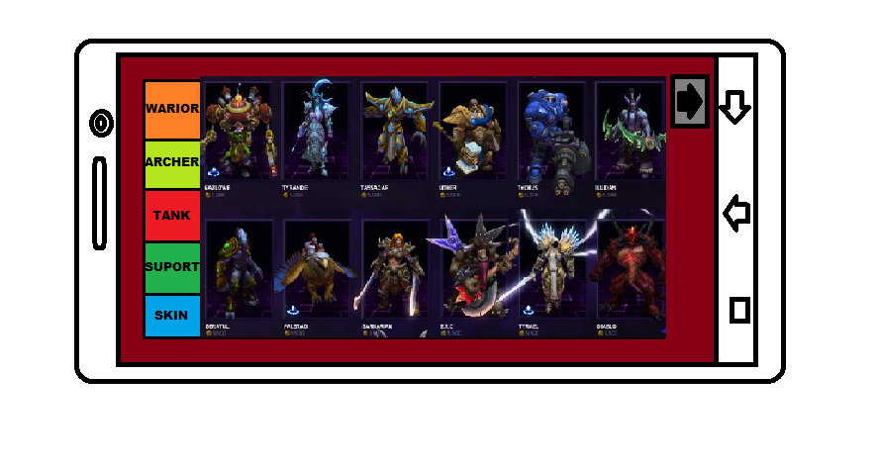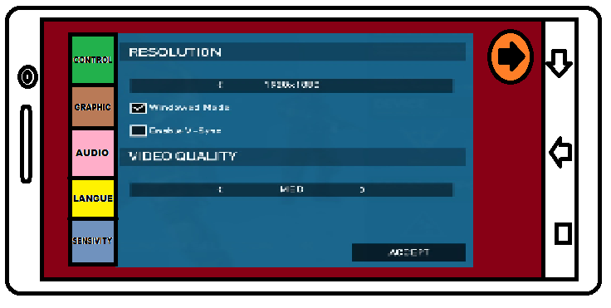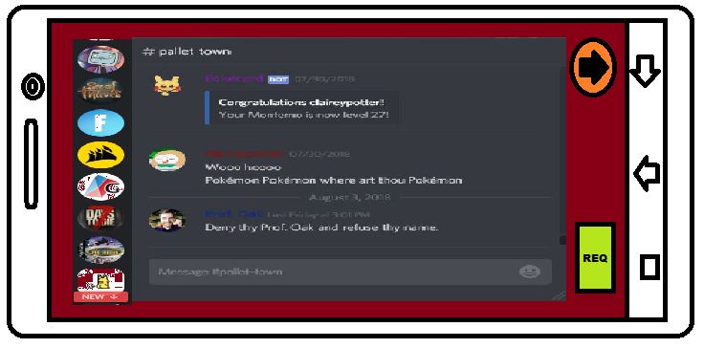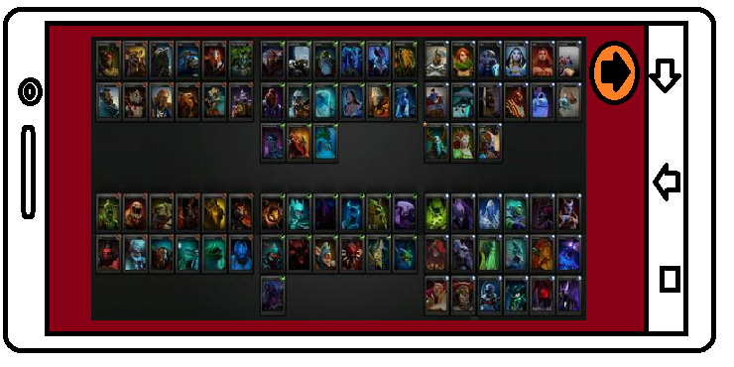

**REFRENCE**

Saya mengambil refrensi dari game moba moba seperti DOTA2, League Of Legends, Vainglory, Arena Of Valor, Mobile Legend karna itu adalh game yg saya tau dan yg dikenal di diindonesia sekarang